email: wgc@activ8.net.au www.warracknabealgolf.com
Clubhouse: [03] 53 982 035
President: 0409 603 922

18.01.2021
And the New Year begins!!
Welcome all to an exciting year at the Warracknabeal Golf Club!! The Bowls Club is ready to take on the new pennant season and the challenge of defending their title. They played Warrack Bowls recently to fire up the adrenalin for their first Saturday match. An enjoyable evening was had and the season begins.
The Golf Club have returned to the course with good numbers and plenty of wind. The Match Committees are planning the fixtures and chasing up sponsors for the events. The fixture book will be ready mid-March.
Hopefully our year will run according to our fixtures unlike last year.
Golf Course
The course is going well as the volunteers continue to do a fantastic job. If you are willing to be an active member contact one of our committee to fit you into a role which assists us to enjoy our golf.
Groundskeeper/Curator
Nigel Zanker, our greens keeper, officially began on Monday 11th January. We look forward to supporting Nigel in his task to keep our greens & fairways to the standard we enjoy. He will have three days at our club and be seconded to Anzac Park for two days of the week.
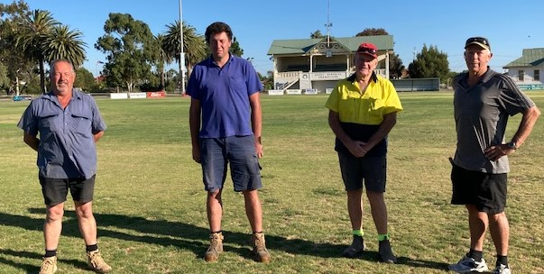
It is a new initiative between the two committees and Nigel will need time to work through the annual expectations placed on him.
Pictured: Greg Pearson, Nigel Zanker, Ian Penny & David Baxter. Greg & Ian are Park Trustee committee members. David is the Golf Club representative. They welcomed Nigel to the town and his work place venues.
Both Anzac Park & our club are reliant on volunteers and active members to create welcoming environments for many people of the district so if you are able to assist in any manner we would appreciate your input.
Our volunteers are reliable and consistent which makes it easier to set up programs and there is always room for that extra hand around the place.
Contact David Baxter 0409 603 922 to be a volunteer.
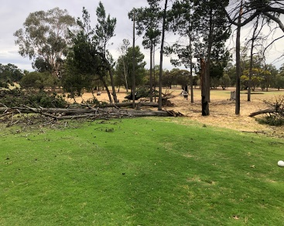
Wild Storm on Freaky Friday – Great Response by Members
New Year’s Eve was an eventful evening as a narrow storm whipped through our course and caused quite an amount of destruction to our sheds and trees.
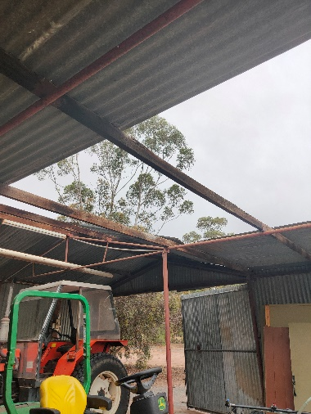
Roofing iron was removed from the tractor shed and work shop while the chemical shed just lifted and went for a holiday. It was totally destroyed but all the chemicals were left sitting on the floor!!
Numerous large trees were toppled while a number of branches of all sizes were on the ground.
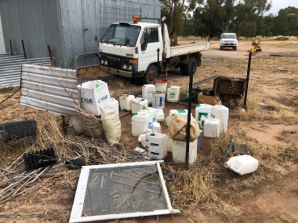
A quick response by some members on the Saturday morning, pushing and pulling branches off tees& fairways, allowed Saturday competition to proceed that day. On Tuesday, the alert & call was put out for a working bee on Wednesday at 1:00pm. A fantastic response of twelve members that afternoon saw most fallen larger trees cut up and the branches put on the rubbish pile. A fabulous effort and a huge thank you to those twelve.
Chemical shed! Where?
Fortunately, for those who could not attend, there are still plenty of smaller branches and areas to be cleaned up so you too can feel great about our course when we return it to a tidy venue.
Sunday, 7th February, will be our targeted working bee. Bring your tools and saws, your trailers and enthusiasm to clean up what we can between 8.00am & 11:00am.
If you have a team tagged to a hole you may even organise a clean-up on your hole before that date!!
Bar Staff
Bar staff are still in short supply so if you are interested in assisting, please contact Peter Barling, House Chairperson.
A ‘Responsible Serving of Alcohol’ certificate is required and it is our intention to run a course at the clubhouse sometime this year. COVID-19 squashed our last attempt to run the course. If interested please contact Peter on 0407 982 233 so we can get the numbers for the course.

RIP
Our condolences to Mick Cheney and Doggie Jess and their families on the passing of our Life Member Claire Cheney. Claire had reached a grand age and obviously has contributed well to our golf & bowls clubs over those many years to be a life member of the club.
Our condolences to our Women’s Captain, Wendy Hewitt, her family and extended family, on the passing of her father, Lindsay Koschitzke, this week. Lindsay reached a grand age of 94.
Congratulations
A nomination by Carolyn Morcom has led to President, David Baxter, receiving a Rotary Australia Day Award for administration in sport. Awards such as these are humbling because you know it wouldn’t happen without the support of the people around you. In this case, the support of Match Committee, Committee, active members and a positive attitude in the club, have led to a number of good things happening within the club over the past five years.
The exciting aspect is that we are expecting good things to continue to happen with the generosity of our members and volunteers over the next three years. Keep yourself involved and enjoy the progress.
Sponsorship
The Committee have selected a subcommittee to review the sponsorship processes and options people & businesses have to choose from. If you have any ideas or sponsors looking for a place at our club, contact Wendy Hewitt, Debby Barling, Allan Ross or David Baxter.
Currently we run with these options:
The Warracknabeal Golf Club appreciates every sponsor it has because it is sponsorship that allows us to provide great golf for the Warracknabeal & District people.
We have a number of ways sponsorship is provided:
Major Sponsorship: Categories are
Diamond $5000, Platinum $1500, Gold $500. This is used at the club’s discretion for the immediate needs.
Tournament Sponsorship:
This is for our Easter & Annual Tournament.
Special Event Sponsorship:
This is events such as Green-Taylor & Partners, Tradies Day or Dianne Marchment & Associates.
Event Sponsorship:
This is an event such as Championships, Board Events, Irish ‘Mulligan’s Day’, May Day, Rocktober.
General Sponsorship:
For weekly events such as Wednesday & Saturday.
Memorial Sponsorship:
This is for families & friends who wish to have an event in memory of a loved one.

Donations:
A number of people donate money to a variety of causes including our machinery account, irrigation account or to special projects. Donations are now tax deductable so please ask for details how this can occur.
Coronavirus
The clubhouse will open under special circumstances upon request with the COVID-19 rules & advice adhered to. If you have a request or enquiry please contact David Baxter, Peter Barling or Shirley Liersch. Otherwise, it will remain closed but the bar will operate for take away drinks. Gatherings are permitted up to 100 people outside & 1to4m2 space inside if the clubhouse is open.
** Visitors please sign in on competition days
** All golfers must sign in on non-competition days for COVID 19 tracking purposes.
Thank you for assisting.
It is very important to read the board and adhere to the very simple items such as:
- Visitors, please sign in or use the QR code.
- Remain 1.5m apart.
- Masks used where distancing is not possible outside.
- Use & handle your own equipment.
- Wash hands in soap and water before & after the round of golf.
- Two to a cart is permitted with the cart being cleaned after use.
- Enjoy your activity by adhering to these suggestions to stay fit & healthy while not putting others at risk.
- If you feel unwell or display any flu-like symptoms Stay Home!! Get tested!!
Thank you
Any queries, please contact me or for up-to-date information, go to the Golf Australia website or the Federal Government have also created a COVID-19 site.

Upcoming events:
Grab those fixture books as we take on the usual competition days. Contact your captains if unsure.
Women: Debby Barling 0417 982 235
Men: Dennis Murphy 0439 195 462

Monday 15th February Vets Golf [AGM]
Saturday 13th March Alex Ross Memorial 9 holes event.

Projects of the future!!
Upgrading our machinery
Painting of the clubhouse and changerooms
Regenerating plant life around the course
Main cool room upgrade.

